To insert dropdown list for 2018 those pages which have this feature:

1. Application Verification – Select Year portion

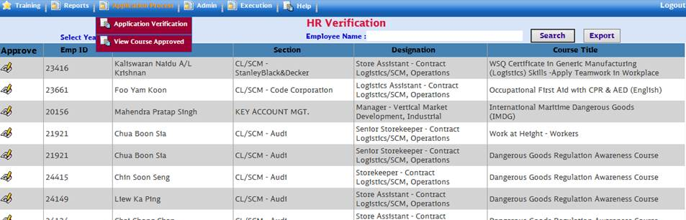

1. View Courses Approved – View Courses Approved for Year and Month

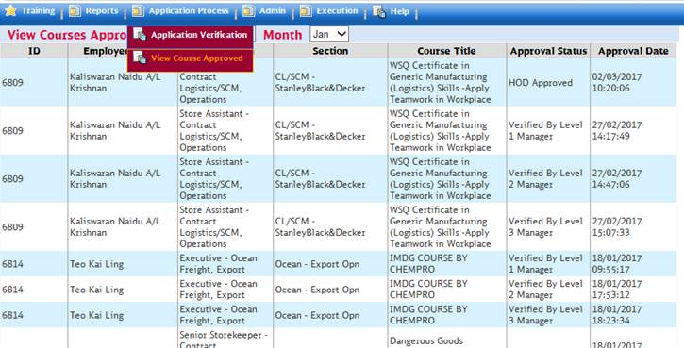

1. Approval Pending List – Remove “2017”

